HVAC Design From Clean Sheet to Blueprint – A Mechanical Designer’s Guide to Design of Small Commercial and Institutional HVAC Systems

Chapter 4 (Partial)
Balancing Outdoor Air and Exhaust Air

Scope

Prior to performing heat loss and heat gain calculations, the minimum required outdoor air to be delivered to the air handling systems must be determined. This is generally determined by local codes, or by good practice where local codes are silent or inadequate. Good practice can be determined by reference to ASHRAE standards, which are also the basis of most code requirements.

Basic Rules

Before cooling and heating loads can be estimated, the amount of outdoor air that will need to be supplied by the building air handlers to each zone must be determined. Throughout this book, outdoor air that is brought into a building through the air conditioning equipment will be referred to as “outdoor air” or “ventilation air”.

In any climate, but most particularly in humid climates such as the Southeast, all buildings must be under positive internal pressure when the cooling systems are operating. There is no standard for the degree of positive pressurization, but in general, an excess of 25% of outdoor ventilation air over exhaust air is considered good practice.
Qoav = 1.25 x Qexh

An exception to this general rule would be if there is a very small amount of minimum required exhaust air, coupled with a relatively small requirement for ventilation air, as may be the case for a small office, or in a zone with no exhaust required. In such a case, outdoor air could exceed exhaust by multiple factors, since the excess air would readily leak out of the building. This would be up to the designer’s judgment. Another exception would be if the amount of exhaust is very large, in which case the ratio of outdoor air to exhaust could be reduced, but never below 1.2. In general, then, exhaust in excess of that required by code is only required to limit pressure loading on exterior doors. In order to limit exterior door pressure loading to five pounds or so, pressure differential should not exceed about .05 inches of water. In any case, however, ventilation air should never fall below 1.2 times exhaust air.

1

There are two ways to determine the minimum ventilation air that must be mechanically supplied to the building. One is by adding the required exhausts and multiplying by 1.25 The other is by determining the minimum “Ventilation for
Acceptable Indoor Air Quality” as calculated from ASHRAE Standard 62.1 based on use and occupant load. The designer should make sure that he or she has the latest issue, since that standard continuously evolves. Both methods must be calculated, and the minimum ventilation air required will be the larger of the two.
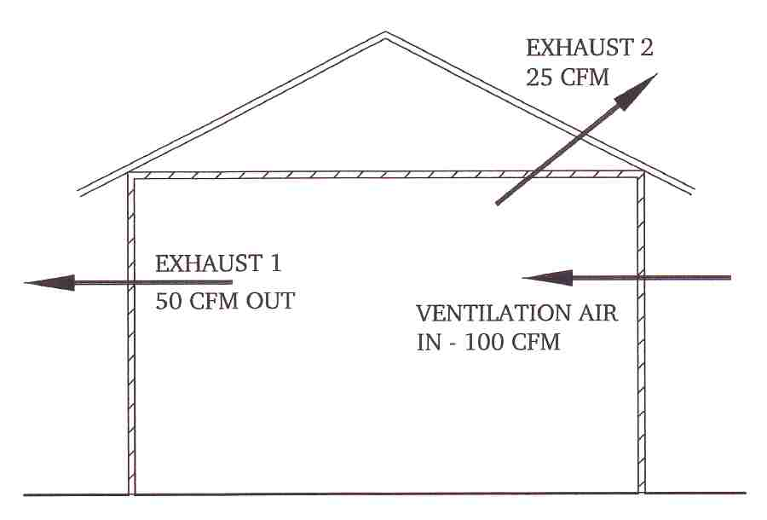
Figure 4-1, Ventilation Air Balance
Mechanical Ventilation and Exhaust

Ventilation Based on Required Exhaust

All local codes have requirements for minimum exhaust from restrooms, lockers, janitor closets, scullery areas, and kitchen fume/grease hoods. Examples from the Florida Uniform Building Code:

Locker Rooms .5 cfm/sf
Shower Rooms 20 cfm/shower head (continuous)
Toilet Rooms 50 cfm per water closet or urinal
Non-commercial kitchen 100 cfm (intermittent)

Commercial kitchens are a special category that are discussed below. If there is no commercial kitchen, then the minimum outdoor air based on required exhaust is found by adding the total of required exhausts and multiplying by 1.25.

Commercial Kitchens

Commercial cooking appliances are required by NFPA standard 96 and by most local codes to be equipped with a hood. The mechanical designer is usually charged with specifying the hood and showing details on the mechanical plans. This is because the requirements for exhaust and make-up air of the kitchen hood system must be integrated into the ventilation air balance of the entire building.
2
A commercial kitchen includes at least three exhaust air zones, each of which may have it’s own exhaust systems. These are: the cooking lineup with NFPA96 grease

at te plane of the fire rated surface.

Summary

Prior to performing heat loss and heat gain calculations, the minimum required outdoor air must be determined. This is generally resolved by local codes, or by good practice where local codes are silent or inadequate. Minimum outdoor air will be the larger of the outdoor air required to offset required exhausts or to meet air quality standards required by local codes or ASHRAE Standard 62.1.

In general, outdoor air must exceed exhaust by a factor of about 1.25 in order to pressurize the building and mitigate infiltration. In some cases, particularly if the building has a commercial kitchen, required exhausts will be large enough that the required offset outdoor air will exceed the outdoor air required to maintain air quality standards. If air quality outdoor air is larger than the required exhaust offset, then supplemental exhaust may be required to prevent over-pressurization of the building.

To make these determinations, the designer should perform an air balance showing all required exhausts, required outdoor air, and supplemental exhaust or outdoor air as needed to provide pressurization. If the building has a commercial kitchen, then air balances should be performed for all expected operational configurations of kitchen exhaust fans. Special controls may be needed to prevent over pressurization or negative pressure. The pressure in the dining areas of a restaurant must always exceed the pressure in the kitchen, and the kitchen pressure must always exceed outside ambient pressure.
END

5

